Press release ifm-pm 832/0825 Area: illumination and signalling

Configurable stackable light towers
Nuremberg, 25 November 2025 – signal lamps attached to machines or plants serve as a visual interface between the machine and the operator. In spacious halls in particular, conditions or faults can be recognised at a glance. The new Dv3xxx stacklights ifm is now presenting at the SPS trade fair offer a particularly flexible and easy-to-configure solution for this.
The two most important requirements customers have for signal lamps are good visibility, even in poor lighting conditions, and high robustness, enabling reliable operation in adverse environmental conditions. The models in the DV3xxx series fulfil these requirements perfectly. These bright LED lights are easy to recognise, even in direct sunlight. They are robust and fulfil protection class IP65, meaning they can be used in harsh industrial environments without any problems. The materials are durable and guaranteed to last a long time – ifm offers a five-year warranty.
The stacklights have a modular design, making them easy to configure. Up to five lights in different colours can be combined, depending on the application. A buzzer can also be added if required. The individual segments are connected to the base module. The segments are controlled via digital inputs supplied with 24 V DC. The stacklights in the DV3xxx series are characterised by their versatility, enabling them to adapt to a wide range of requirements with ease. For instance, individual segments can be replaced or supplemented as needed. A segment with a different colour or an additional buzzer can be installed in just a few simple steps. Stacklights are typically used on processing machines, assembly lines, packaging machines, filling systems and many other types of machines and installations where status visualisation is required.
ifm at SPS: hall 7A, stand 302

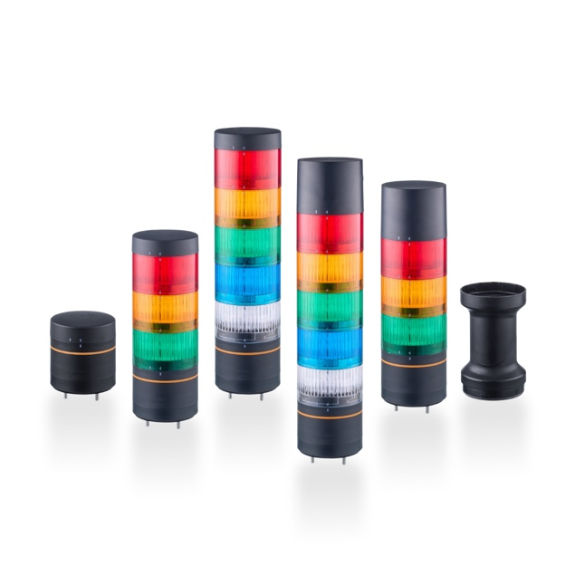 | ifm-pm 832 print.jpg  The new light towers from ifm are easy to configure and offer reliable visualisation of machine statuses.

About the ifm group of companies

From a passion, to an idea, to success. Since its foundation in 1969, ifm has developed, produced and sold sensors, controllers, software and systems for industrial automation and for SAP-based solutions for supply chain management and shop floor integration worldwide. As one of the pioneers of Industry 4.0, ifm develops and implements consistent solutions to digitalise the entire value chain “from sensor to ERP”. Today, the second-generation family-run ifm group has more than 8,760 employees and is one of the worldwide market leaders. The group combines the internationality and innovative strength of a growing group of companies with the flexibility and close customer contact of a medium-sized company.
Printing free of charge – reference copy requested.

Editorial enquiries  Agentur Dr. Lantzsch  Jörg Lantzsch  Müllerstr. 5  65183 Wiesbaden  www.drlantzsch.de  Tel.: +49 611 205 93 71  Email: info@drlantzsch.de | Contact  ifm electronic gmbh  Simone Felderhoff  Friedrichstr. 1  45128 Essen  www.ifm.com  Tel.: +49 201 24 22 0  Fax: +49 201 24 22 1200  Email: presse@ifm.com

